

**CC4057NI  
 60% Group Coursework**

**2023/24 Autumn**

|  |  |  |  |
| --- | --- | --- | --- |
| **Group Name:** | | | |
| **SN** | **Student Name** | **College ID** | **University ID** |
|  | **Chetan Jung Neupane** | NP01NT4A230019 | 23047324 |
|  | **Imamuddin Dhobi** | NP01NT4A230004 | 23048513 |
|  | **MD.FIAZUR RAHMAN RAIN** | **NP01NT4A230001** | 23047304 |
|  | **Krish Khadka** | NP01NT4S220213 | **220213** |

**Assignment Due Date: Wednesday, January 31, 2024**

**Assignment Submission Date: Sunday, July 21, 2024**

**Word Count: 6028**

**Project File Links:**

|  |  |
| --- | --- |
| **YouTube Link:** | Keep Unlisted YouTube URL of your Project Here |
| **Google Drive Link:** | Keep Google Drive URL of your Project Here with Anyone in Organization can View Option Enabled |

*I confirm that I understand my coursework needs to be submitted online via MySecondTeacher under the relevant module page before the deadline in order for my assignment to be accepted and marked. I am fully aware that late submissions will be treated as non-submission and a marks of zero will be awarded.*

Table of Contents

1.Introduction 1

1.1 Goal and Objectives 1

1.2 Use of HTML, CSS, JS 1

1.2.1 HTML 1

1.2.2 CSS 2

1.2.3 JS 3

1.3 Tools used in this project 3

1.3.1 VS Code 3

1.3.2 Balsamiq 4

2.Page description 4

2.1 Home page 4

2.2 Product page 5

2.3 Blog Page 7

2.4 Research Page 8

2.5 About page 10

3. Testing 11

3.1 Testing NAV hovering effect 11

3.2 Testing Image Slider 12

3.3 Testing the login icon 14

3.4 Testing the alert message 15

3.5 Testing the Internal link 16

3.6 Testing the External link 17

4.Conclusion 18

5. Bibliography 19

6.Appendix 20

**Table of Figures**

Figure 1 Html logo 2

Figure 2 CSS Logo 2

Figure 3 JS logo 3

Figure 4 Wireframe of home page 4

Figure 5 Home page 5

Figure 6 Wireframe of Product page 5

Figure 7 Product page 6

Figure 8 Wireframe of Blog page 7

Figure 9 Blog page 8

Figure 10 Wireframe of research page 8

Figure 11 Research page 9

Figure 12 Wireframe of About us 10

Figure 13 About us 11

Figure 14 Color before placing cursor 12

Figure 15 Color changing after pointing cursor 12

Figure 16 Home Page every 1 sec 13

Figure 17 Before clicking login icon 14

Figure 18 After clicking login icon 14

Figure 19 Before Filling the form 15

Figure 20 After filling the form 15

Figure 21 Before clicking the product Button 16

Figure 22 After clicking the product Button 16

Figure 23 Clicking the Facebook icon 17

Figure 24 After clicking Facebook icon 17

**Table of Tables**

Table 1 Testing the hover effect on Nav Bar 11

Table 2 Testing Image Slider 12

Table 3 Testing login icon 14

Table 4 Testing the alert message 15

Table 5 Testing internal link 16

Table 6 Testing external link 17

# 1.Introduction

This project is an e-commerce website of a store named as DOMINION which sells various types of printers. We have created a 5 web pages website (Home, Product, Blog, Research and About us section). Every page has a header and footer section. Where home page consists of the motto of our website whereas the display of the printer is done there. And details of every page are shown there. Whereas the Product page consists of printer which are listed for sale with discounted price. Blog page consists of demonstration about how technology has affected daily life and business. Also, the research page consists of comparison between successful website and our website. And the about us section consist of detailed portfolio of our team member and a feedback form.

This project is done in VSCODE with help of HTML, CSS and JS. This project is completed with proper structured code as well as comments on the code. Proper use of tags can be seen in the project. Navigation bar is structured in proper way, and it can be fully navigated. Internal, Inline and external CSS is used to create this project.

## 1.1 Goal and Objectives

Developing this website will give us ability to create a website using the right tools and technologies. It will help us to recognise the website's basic navigational principles and structure. Helps us to gain knowledge of factors to consider while designing a website, such as accessibility and usability. Also, it will give knowledge of the fundamentals of Internet technology and the effects it has had on people’s daily lives.

## 1.2 Use of HTML, CSS, JS

### 1.2.1 HTML

Hypertext Markup Language (HTML) is the set of markup symbols or codes inserted into a file intended for display on the internet. The markup tells web browsers how to display a webpage's words and images. Each individual piece markup code is an element, though many people also refer to it as a tag. Some elements come in pairs that indicate when some display effect is to begin and when it is to end. (HAYES, 2022 )



Figure 1 Html logo

### 1.2.2 CSS

Cascading Style Sheets, affectionately referred to as CSS, is a simple design language intended to simplify the process of making web pages presentable.CSS handles the look and feel part of a web page. Using CSS, you can control the color of the text, the style of fonts, the spacing between paragraphs, how columns are sized and laid out, what background images or colors are used, layout designs, variations in display for different devices and screen sizes as well as a variety of other effects (Jaiswal, 2022)



Figure 2 CSS Logo

### 1.2.3 JS

JavaScript (JS) is a light-weight object-oriented programming language which is used by several websites for scripting webpages. This is an interpreted, full-powered programming language which enables dynamic interactivity in websites as applied to an HTML document. It was introduced in the year 1995 to attach programs to the webpages in the Netscape Navigator browser. Since then, it has been adopted by all other graphical web browsers. JavaScript allows users to create modern web applications that can communicate directly without having to reload the page every now and then. Traditional websites use JS for various forms of interactivity and ease (Jaiswal, 2022).



Figure 3 JS logo

## 1.3 Tools used in this project

### 1.3.1 VS Code

Visual Studio Code is a free, lightweight but powerful source code editor that runs on your desktop and on the web. It is available for Windows, macOS, Linux, and Raspberry Pi OS. Visual Studio comes with out-of-the-box support for JavaScript, TypeScript, and Node.js, and has a rich extension ecosystem for other programming languages (C++, C#, Java, Python, PHP, Go), runtime (such as .NET and Unity), environments (such as Docker and Kubernetes), or clouds (Amazon Web Services, Microsoft Azure, and Google Cloud Platform) (Heller, 2022).

### 1.3.2 Balsamiq

Balsamiq Wireframes is a user interface design tool to create wireframes, sometimes referred to as mockups or low-fidelity prototypes. You could use it to create digital sketches of your idea or concept for an application or website in order to discuss and understand it better before the writing of any code. The completed wireframes can be used in user testing, clarification of the vision, gaining input from stakeholders, or gaining approval to start development (Balsamiq, 2008).

# 2.Page description

Every page consists of a different design and has different objective too. Every page is

designed according to the wireframe and have distinct character.

## 2.1 Home page

The home page is also the display page of our website. It consists of navigation bar in the top and the name of the store in the top left. It consists of 2 parts on the left side of the page displaying the motto of the company and a slogan and down left side there is a brief description of every page with the anchor with every line. On the bottom right there is the display on the printer which is available on our website, and it changes as JS is used. Down you can see the footer section with a copy right of our company name.

Figure 4 Wireframe of home page

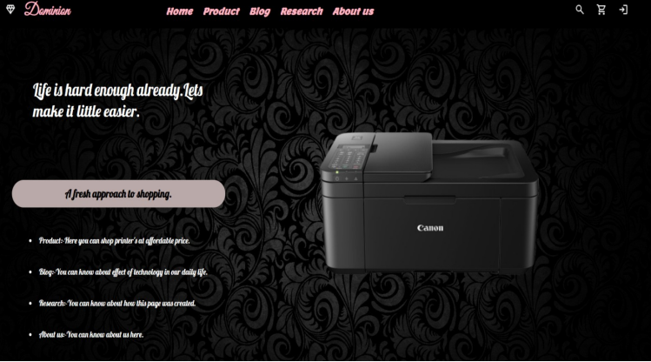

Figure 5 Home page

## 2.2 Product page

This page consists of the product details in the store. Here is the list of printers and all the printers are displayed in the box. Printers are displayed with actual price and discounted price. The page also consists of the navigation bar and footer. Footer consists of store detail too. The products are displayed with proper company name and image.

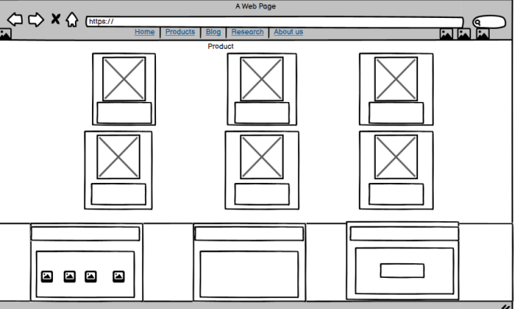

Figure 6 Wireframe of Product page

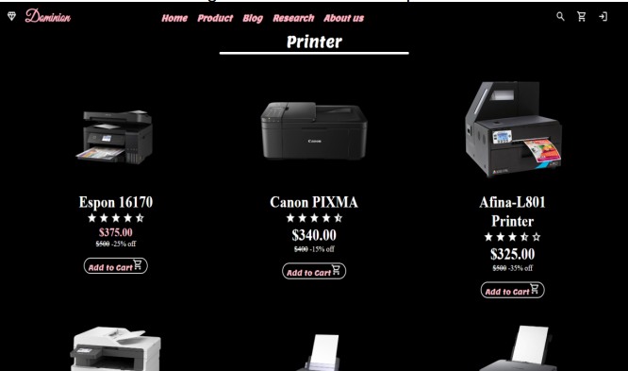

Figure 7 Product page

## 2.3 Blog Page

This page consists of the blog article on the impact of the technology in our daily life. It consists of two blog and a footer. The blog is divided in 2 parts. One topic consists of impact in life and another impact on business.

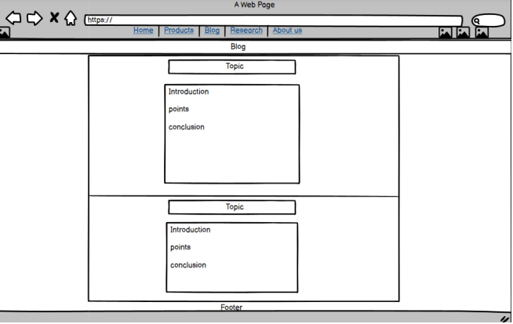

Figure 8 Wireframe of Blog page

Figure 9 Blog page

## 2.4 Research Page

This page consists of the comparison between the various website and our website. This shows the comparison about how different pages are and how we 10 took reference from it. We displayed it in the tabular form and also it contains the footer.

Figure 10 Wireframe of research page

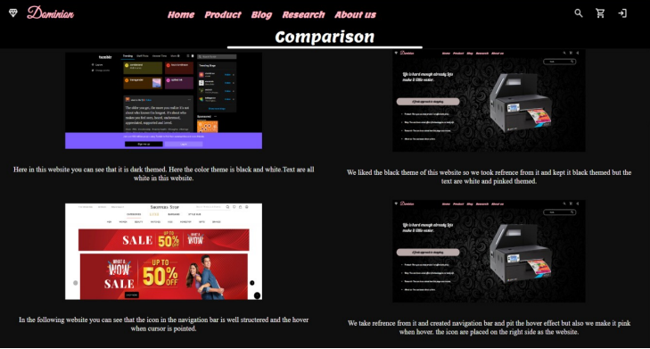

Figure 11 Research page

## 2.5 About page

This page consists of the detail portfolio of our team member, and it consist of the feedback form in the lower section. It consists of image and experiences of our team member.

Figure 12 Wireframe of About us

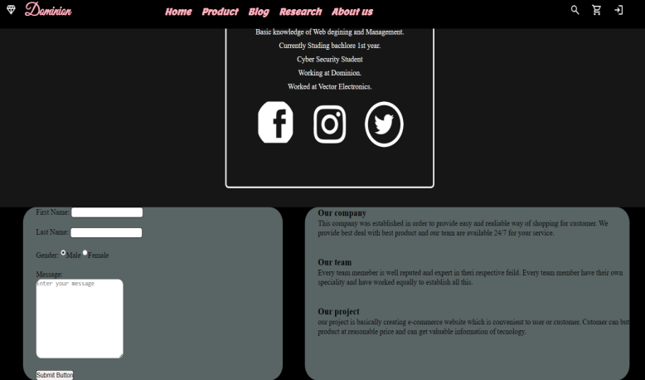

Figure 13 About us

# 3. Testing

## 3.1 Testing NAV hovering effect

|  |  |
| --- | --- |
| Objective | Testing the hover effect on nav bar. |
| Action | Placing the cursor on the text to see the hover Effect. |
| Expected Result | The colour should change while pointing cursor. |
| Actual Result | The colour changed while pointing cursor. |
| Conclusion | Text is successful. |

Table 1 Testing the hover effect on Nav Bar

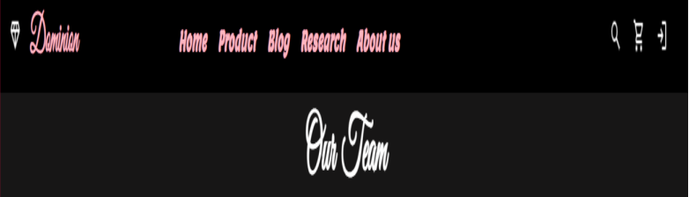

Figure 14 Color before placing cursor

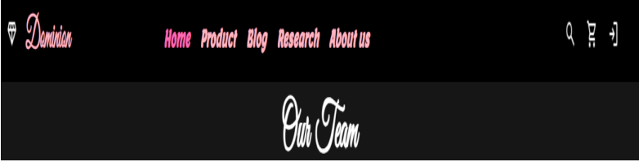

Figure 15 Color changing after pointing cursor

## 3.2 Testing Image Slider

|  |  |
| --- | --- |
| Objective | To check the image slider. |
| Action | Just open the home page. |
| Expected Result | The image should change automatically every 1 sec. |
| Actual Result | The image changed automatically every 1 sec. |
| Conclusion | Test is successful. |

Table 2 Testing Image Slider

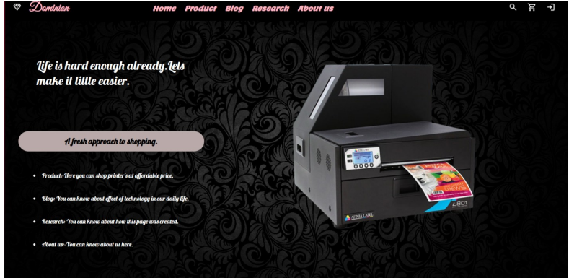

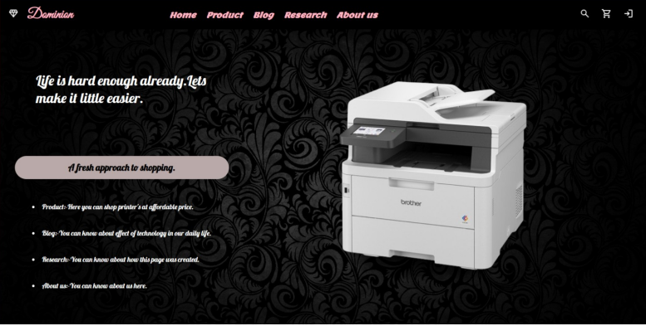

Figure 16 Home Page every 1 sec

## 3.3 Testing the login icon

|  |  |
| --- | --- |
| Objective | To check the login in portal. |
| Action | Click the login icon to access the login box |
| Expected result | Login box should appear in 1 sec. |
| Actual result | Login box appeared in 1 sec. |
| Conclusion | Test is successful. |

Table 3 Testing login icon

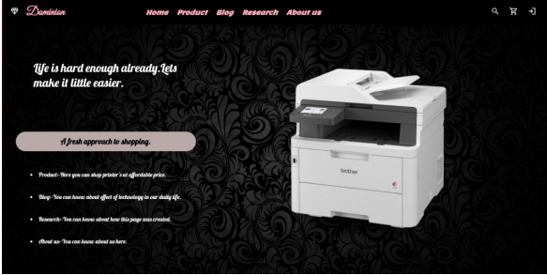

Figure 17 Before clicking login icon

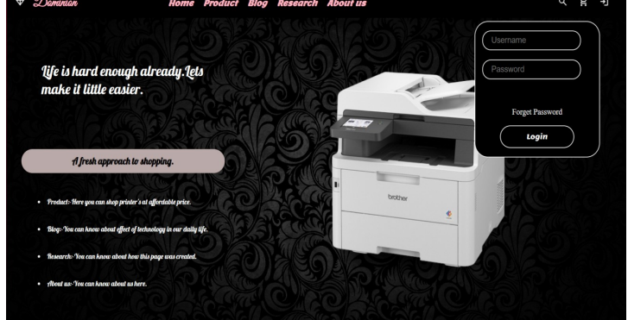

Figure 18 After clicking login icon

## 3.4 Testing the alert message

|  |  |
| --- | --- |
| Objective | To check whether the alert box appears or not after filling the feedback form |
| Action | Fill the feed Back form. |
| Expected Result | Alert box should appear with a message. |
| Actual Result | Alert boxes appear with a message |
| Conclusion | Test is successful. |

Table 4 Testing the alert message

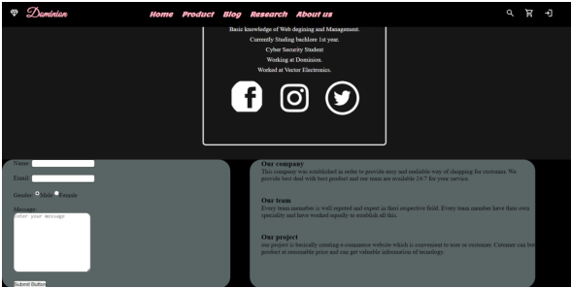

Figure 19 Before Filling the form

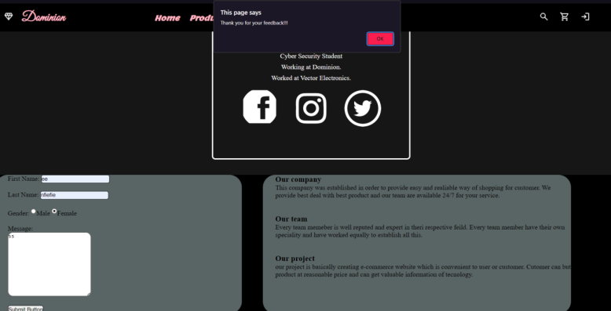

Figure 20 After filling the form

## 3.5 Testing the Internal link

|  |  |
| --- | --- |
| Objective | Testing Internal Link |
| Action | Clicking on the product on the nav bar from home page. |
| Expected result | Product page should open. |
| Actual Result | Product page has opened. |
| Conclusion | Test is successful. |

Table 5 Testing internal link

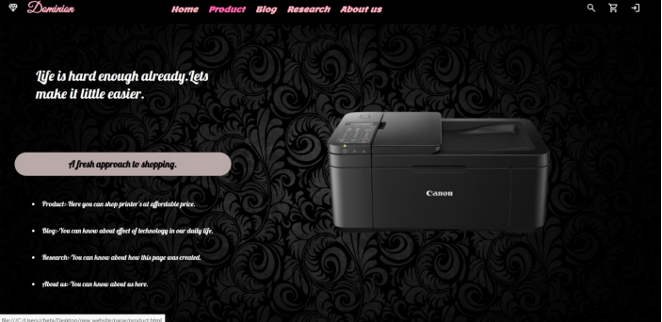

Figure 21 Before clicking the product Button

Figure 22 After clicking the product Button

## 3.6 Testing the External link

|  |  |
| --- | --- |
| Objective | Testing External Link |
| Action | Clicking on the Facebook icon from about us section. |
| Expected result | Facebook page should open. |
| Actual Result | Facebook page has opened. |
| Conclusion | Test is successful. |

Table 6 Testing external link

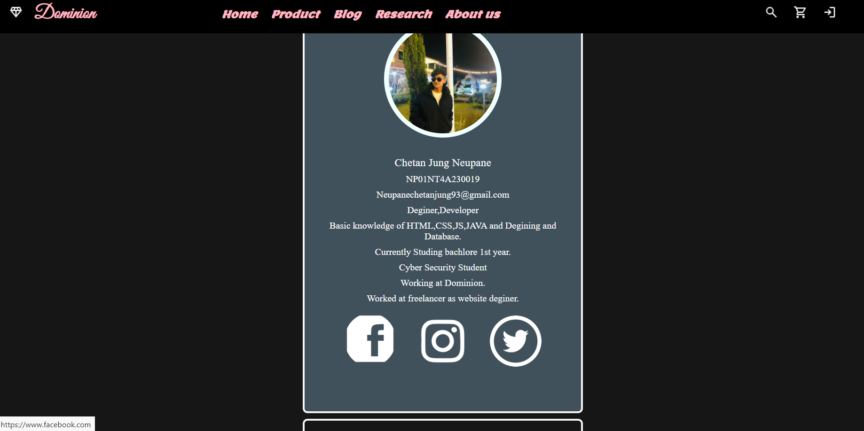

Figure 23 Clicking the Facebook icon

Figure 24 After clicking Facebook icon

# 4.Conclusion

Following project was our first experience as working as team, though it was hard for us to conclude, we took advice from teacher, friends, and exploring some websites and doing some research we have finally completed my project on time. We followed all the instruction mentioned and all of the course work is carefully completed, well documented, and present in this report.

Completing this project created us chance to learn the process very deeply and now we can create different web pages as instructed. And we learned about linking different web pages. Now we are aware about using the correct CSS and adding java script. As it is our first project as team, we it was quite a challenge for us but with help of teacher proper guidance and taking advice from some of my friend and taking reference from some websites we completed this project very easily and learned many new things. Now we know how to make different pages, link pages, also about the CSS and java script.

It was hard for us to structure the code correctly since our testing was continuously giving the opposite output than we expected. It was a very irritating and frustrating to not receive the desire output. But we act calmly and look after the solution and take out the instructed output at last.

At last, after proper guidance and our effort, we were able to finish our coursework at the end. Completing this project taught us many things such as time management, making a learning habit and about web designing. We want to thank our teacher and friend who provide me proper guidance and taught us well and cleared our confusion. We wouldn’t have completed this project without them.

# 5. Bibliography

Balsamiq, 2008. *balsamiq.* [Online]   
Available at: https://balsamiq.com/wireframes/desktop/docs/intro/  
[Accessed 2024].

HAYES, A., 2022 . *Investopedia.* [Online]   
Available at: https://www.investopedia.com/terms/h/html.asp  
[Accessed 2024].

Heller, M., 2022. *InfoWorld.* [Online]   
Available at: https://www.infoworld.com/article/3666488/what-is-visual-studio-code-microsofts-extensible-code-editor.html  
[Accessed 2024].

Jaiswal, S., 2022. *Javatpoint.* [Online]   
Available at: https://www.javatpoint.com/  
[Accessed 2024].

# 6.Appendix

## 6.1 Code of home page

<!DOCTYPE html>

<html lang="en">

    <head>

        <!-- Document metadata and title -->

        <title>Home</title>

        <meta name="description" content="Dominion">

        <link rel="stylesheet"  href="css/style.css"> <!-- Linking to the external stylesheet -->

    </head>

    }

    <style>

        body{ /* Styling for the body, including background image */

            background-image: url(image/background.jpg);

            background-size: cover;

            background-repeat: no-repeat;

        }

         /* Main content section */

        .maintext{

        width: 95%;

        height: 90%;

        background-color: transparent;

        position: absolute;

        top: 9%;

        left: 2%;

        display: flex;

        align-items: center;

        justify-content: flex-start;

        }

        .leftside /* Styles for the left side content */

        {

        width: 35%;

        height: 100%;

        background: transparent;

        display: flex;

        align-items: center;

        flex-direction: column;

        justify-content: space-evenly;

        padding: 5px;

        font-family: font3;

        }

        .first{ /* Styles for the first content block within the left side */

        width: 100%;

        background-color: transparent;

        color: white;

        height: 30%;

        font-size: xx-large;

        padding: 10%;

        align-items: center;

        }

        .second{/* Styles for the second content block within the left side */

        width: 100%;

        height: 8%;

        background-color: rgb(186, 169, 169);

        border-radius: 50px;

        display: flex;

        align-items: center;

        justify-content: center;

        font-size: large;

        text-align: center;

        }

        .list li{ /* Styles for the list items within the left side */

        color: white;

        padding: 10px;

        cursor: pointer;

        }

        .list li:hover{ /* Styles for the list items on hover */

        color: bisque;

        word-spacing: 2px;

        font-size: medium;

        }

        .rightside   /* Styles for the right side content */

        {

        width: 65%;

        height: 100%;

        background: transparent;

        display: flex;

        align-items: center;

        justify-content: center;

        overflow: hidden;

        }

    </style>

    <body>

        <div class="container">

        <header class="header">

             <!-- Header content goes here -->

            <div class="logo">

                <a href="#"><img src="css/diamonf.png" style="filter:brightness(0) invert(1); ">

                </a>

                <a href="#"><h2>Dominion</h2></a>

            </div>

            <nav class="nav">

                    <!-- Navigation links -->

                       <a href="#"><b><i>Home</i></b></a></th>

                       <a href="page/product.html"><i><b>Product</b></i></a>

                        <a href="page/blog.html"><i><b>Blog</b></i></a>

                        <a href="page/research.html"><i><b>Research</b></i></a>

                        <a href="page/about us.html"><i><b>About us</b></i>

            </nav>

            <div class="icon">

                <a id="search" href="#"><img src="css/search.png" style="filter: brightness(0) invert(1);">

                </a>

            <a href="#">

              <img src="css/shopping.png" style="filter: brightness(0) invert(1);">

            </a>

            <a id="login" href="#">

                <img src="css/login.png" style="filter: brightness(0) invert(1);">

            </a>

            </div>

        </header>

        </div>

        <div class="maintext"> <!-- Main content section -->

            <div class="leftside"> <!-- left content section -->

                <div class="first">

                 <p>Life is hard enough already.Lets make it little easier. </p>

                </div>

                <div class="second">

                    <h3>A fresh approach to shopping.</h3>

                </div>

                <div class="list"><!-- List of links -->

                        <a href="page/product.html"><li>Product:-Here you can shop printer's at affordable price.</li></a>

                        <br>

                        <a href="page/blog.html"><li>Blog:-You can know about effect of technology in our daily life.</li></a>

                        <br>

                        <a href="page/research.html"><li>Research:-You can know about how this page was created.</li></a>

                        <br>

                        <a href="page/about us.html"><li>About us:-You can know about us here.</li></a>

                        <br>

                </div>

            </div>

            <div class="rightside"> <!-- Right side content -->

                <div id="img">

                <img src="image/printer1.png" width="70%" height="70%">

                </div>

            </div>

            <script>// JavaScript for image slider

                 var images = [ 'image/printer2.png', 'image/printer3.png', 'image/printer4.png',];

                    var x = 0;

                    var imgs = document.getElementById('img');

                    //The setInterval() calls a function at theintervals (in milliseconds).

                    setInterval(slider, 3000);

                    function slider() {

                    if (x < images.length)

                        {

                        x = x + 1;

                        }

                    else

                        {

                        x = 1;

                        }

                    imgs.innerHTML = "<img src=" + images[x - 1] + ">";

                    }

            </script>

        <div class="searchbar"><!-- Search bar section -->

         <h1>Search......</h1>

         <a href="#"><img src="css/search.png" style="filter: brightness(0) invert(1);">

         </div>

        <div class="login">

            <input type="text" id="username" placeholder="Username"><br><br>

            <input type="text" id="password" placeholder="Password">

            <a href="#">Forget Password</a>

            <button>Login</button>

        </div>

        <script src="script.js">

        </script>

    </body>

</html>

## 6.2 Code of Product page

<!DOCTYPE html>

<html lang="en">

    <head>

        <title>Product</title>

        <meta name="" content="">

        <link rel="stylesheet"  href="../css/style.css">

    </head>

    <style>

        body{/* Styling for the body, including background image */

            background-image: url(../image/background.jpg);

            background-size: cover;

            background-repeat: no-repeat;

        }

         .container2/* Styling for the container2 */

        {

            width: 100%;

            height: auto;

            background: black;

        }

        .heading/* Styling for the heading section */

        {

            color: white;

            background: black;

            font-size: xx-large;

            padding-top: 60px;

            text-align: center;

            font-family: font2;

        }

        .underline{  /* Styling for the underline effect */

            background: white;

            height: 5px;

            width: 30%;

            position: relative;

            border-radius: 10px;

            left: 35%;

        }

        .printer{

    /* Styling for the printer section */

        width: 100%;

        height: auto;

        background-color: transparent;

        display: flex;

        align-items: center;

        justify-content: space-evenly;

        flex-wrap: wrap;

        }

        .products{

        width: 250px;

        background: transparent;

        height: 350px;

        color: white;

        display: flex;

        align-items: center;

        justify-content: space-around;

        flex-direction: column;

        margin-top: 64px;

        margin: 64px;

        transition: 0.5s;

        border-radius: 16px;

        }

        .products button{/* Styling for buttons inside product cards */

        width: 60%;

        height: 30%;

        margin-bottom: 16px;

        font-family: font2;

        color: pink;

        font-size: medium;

        }

        .top/* Styling for the top section of product cards */

        {

        width: 100%;

        height: 60%;

        background: transparent;

        display: flex;

        align-items: center;

        justify-content: center;

        }

        .top img{   /* Styling for product images inside product cards */

        width: 100%;

        height: 100%;

        }

        .bottom /* Styling for the bottom section of product cards */

        {

        width: 100%;

        height: 45%;

        background: transparent;

        display: flex;

        justify-content: space-between;

        align-items: center;

        flex-direction: column;

        margin-top: 16px;

        }

        .bottom h3{    /* Styling for various text elements in the product cards */

        font-size: xx-large;

        text-align: center;

        color: white;

        }

        .bottom h4{

        font-size: x-large;

        color: pink;

        }

        .products:hover{/* Hover effect for product cards */

        cursor: pointer;

        background: black;

        width: 300px;

        height: 450px;

        border: 2px solid whitesmoke;

        }

        .discount

        {

        text-decoration: line-through;

        }

    </style>

    <body>

        <div class="container">

<!-- Header section -->

        <header class="header">

<!-- Logo section -->

            <div class="logo">

                <a href="../home.html"><img src="../css\diamonf.png" style="filter: brightness(0) invert(1);">

                </a>

                <a href="../home.html"><h2>Dominion</h2></a>

            </div>

            <nav class="nav"><!-- Logo section -->

                            <a href="../home.html"><b><i>Home</i></b></a></th>

                            <a href="#"><i><b>Product</b></i></a>

                            <a href="blog.html"><i><b>Blog</b></i></a>

                        <a href="research.html"><i><b>Research</b></i></a>

                        <a href="about us.html"><i><b>About us</b></i>

            </nav>

            <div class="icon">   <!-- Icon section -->

                <a href="#"><img src="../css/search.png" style="filter: brightness(0) invert(1);">

                    </a>

                <a href="#">

                  <img src="../css/shopping.png" style="filter: brightness(0) invert(1);">

                </a>

                <a href="#">

                    <img src="../css/login.png" style="filter: brightness(0) invert(1);">

                </a>

            </div>

        </header>

        </div>

        <div class="container2">

            <P class="heading">Printer</P>

            <div class="underline"></div>

            <div class="printer"> <!-- Script for displaying date -->

                        <!-- Product items section -->

                    <div class="products"> <!-- Top part of the product -->

                        <div class="top">

                            <img src="../image/printer1.png">

                        </div>

                        <div class="bottom"> <!-- Bottom part of the product -->

                            <h3>Espon 16170 </h3>

                            <p><img src="../css\star.png"style="filter:  brightness(0) invert(1);">

                            <img src="../css\star.png"style="filter:  brightness(0) invert(1);">

                            <img src="../css\star.png"style="filter:  brightness(0) invert(1);">

                            <img src="../css\star.png"style="filter:  brightness(0) invert(1);">

                            <img src="../css\half star.png"style="filter:  brightness(0) invert(1);"></p>

                            <h4>$375.00</h4>

                            <p><del class="discount">$500</del> -25% off</p> <br>

                            <button>Add to Cart<img src="../css\shopping.png" style="filter:  brightness(0) invert(1);"></button>

                        </div>

                    </div>

                    <div class="products">

                        <div class="top">

                            <img src="../image/printer2.png">

                        </div>

                        <div class="bottom">

                            <h3>Canon PIXMA </h3>

                            <p><img src="../css/star.png"style="filter:  brightness(0) invert(1);">

                            <img src="../css/star.png"style="filter:  brightness(0) invert(1);">

                            <img src="../css\star.png"style="filter:  brightness(0) invert(1);">

                            <img src="../css\star.png"style="filter:  brightness(0) invert(1);">

                            <img src="../css\half star.png"style="filter:  brightness(0) invert(1);"></p>

                            <h3>$340.00</h3>

                            <p><del class="discount">$400</del> -15% off</p> <br>

                            <button>Add to Cart<img src="../css\shopping.png" style="filter:  brightness(0) invert(1);"></button>

                        </div>

                    </div>

                  <div class="products">

                        <div class="top">

                            <img src="../image/printer3.png">

                        </div>

                        <div class="bottom">

                            <h3>Afina-L801 Printer</h3>

                            <p><img src="../css\star.png"style="filter:  brightness(0) invert(1);" >

                            <img src="../css\star.png"style="filter:  brightness(0) invert(1);">

                            <img src="../css\star.png"style="filter:  brightness(0) invert(1);">

                            <img src="../css\half star.png"style="filter:  brightness(0) invert(1);">

                            <img src="../css\empty star.png"style="filter:  brightness(0) invert(1);"></p>

                            <h3>$325.00</h3>

                            <p><del class="discount">$500</del> -35% off</p> <br>

                            <button>Add to Cart<img src="../css\shopping.png" style="filter:  brightness(0) invert(1);"></button>

                        </div>

                    </div>

                    <div class="products">

                        <div class="top">

                            <img src="../image/printer4.png">

                        </div>

                        <div class="bottom">

                            <h3>Brother MFC</h3>

                            <p><img src="../css\star.png"style="filter:  brightness(0) invert(1);">

                            <img src="../css\star.png"style="filter:  brightness(0) invert(1);">

                            <img src="../css\star.png"style="filter:  brightness(0) invert(1);">

                            <img src="../css\star.png"style="filter:  brightness(0) invert(1);">

                            <img src="../css\empty star.png"style="filter:  brightness(0) invert(1);"></p>

                            <h3>$30.00</h3>

                            <p><del class="discount">$900</del> -40% off</p> <br>

                            <button>Add to Cart<img src="../css\shopping.png" style="filter:  brightness(0) invert(1);"></button>

                        </div>

                    </div>

                    <div class="products">

                        <div class="top">

                            <img  src="../image/printer5.png">

                        </div>

                        <div class="bottom">

                            <h3>Epson Eco tank</h3>

                            <p><img src="../css\star.png"style="filter:  brightness(0) invert(1);">

                            <img src="../css\star.png"style="filter:  brightness(0) invert(1);">

                            <img src="../css\star.png"style="filter:  brightness(0) invert(1);">

                            <img src="../css\star.png"style="filter:  brightness(0) invert(1);">

                            <img src="../css\half star.png"style="filter:  brightness(0) invert(1);"></p>

                            <h3>$576.00</h3>

                            <p><del class="discount">$768</del> -25% off</p> <br>

                            <button>Add to Cart<img src="../css\shopping.png" style="filter:  brightness(0) invert(1);"></button>

                        </div>

                   </div>

                  <div class="products">

                        <div class="top">

                            <img src="../image/printer6.png">

                        </div>

                        <div class="bottom">

                            <h3>Canon Pixma TS</h3>

                            <p><img src="../css\star.png"style="filter:  brightness(0) invert(1);">

                            <img src="../css\star.png"style="filter:  brightness(0) invert(1);">

                            <img src="../css\star.png"style="filter:  brightness(0) invert(1);">

                            <img src="../css\star.png"style="filter:  brightness(0) invert(1);">

                            <img src="../css\half star.png"style="filter:  brightness(0) invert(1);"></p>

                            <h3>$570.00</h3>

                            <p><del class="discount">$600</del> -5% off</p> <br>

                            <button>Add to Cart<img src="../css\shopping.png" style="filter:  brightness(0) invert(1);"></button>

                        </div>

                </div>

            </div>

        </div>

        <div class="footer">

            <!-- Footer section -->

            <div class="upper">      <!-- Upper part of the footer with company information -->

                <div class="u">

                    <h1><img src="../css/diamonf.png" style="filter: brightness(0) invert(1);">Dominion</h1>

                    <p>We provide the best quality product and best sales service. Get every product here at cheapest price.</p>

                    <div class="images">

                        <img src="../image/facebook.png">

                        <img src="../image/instagram.png">

                        <img src="../image/twitter.png">

                    </div>

                </div>

                <div class="u">

                    <h1>Contact Info</h1>!-- Connect with us section -->

                    <div class="footericon">

                        <div class="matter"><img src="../css/call.png" style="filter: brightness(0) invert(1);">+977 9845678992</div>

                        <div class="matter"><img src="../css/call.png" style="filter: brightness(0) invert(1);">+977 9865789546</div>

                        <div class="matter"><img src="../css/mail.png" style="filter: brightness(0) invert(1);">dominion878@gmail.com</div>

                        <div class="matter"><img src="../css/location.png" style="filter: brightness(0) invert(1);">Balaju,Kathmandu,Nepal</div>

                    </div>

                </div>

                <div class="u"><-- Connect with us section -->

                    <h1>Connect with us</h1>

                    <p>Get all the latest updates on product and never miss anything.</p>

                    <input class="input" type="email" placeholder="Enter email">

                    <button>Suscribe</button>

                </div>

            </div>

            <div class="lower">    <!-- Lower part of the footer with copyright information -->

                <h2>&copy Dominion</h2>

            </div>

        </div>

    </body>

</html>

## 6.3 Code of Blog page

<!DOCTYPE html>

<html lang="en">

    <head>

        <title>Blog</title>

        <meta name="" content="">

        <link rel="stylesheet"  href="../css/style.css">

    </head>

    <style>

        body{ /* Global styles for the entire body */

            background-image: url(../image/background.jpg);

            background-size: cover;

            background-repeat: no-repeat;

        }

        .container2/* Container2 styles */

        {

            width: 100%;

            height: auto;

            background: black;

        }

        .heading

        {   /* Heading styles */

            color: white;

            background: black;

            font-size: xx-large;

            padding-top: 60px;

            text-align: center;

            font-family: font2;

        }

        .underline{

    /* Underline styles */

            background: white;

            height: 5px;

            width: 30%;

            position: relative;

            border-radius: 10px;

            left: 35%;

        }

        .underline2{

    /* Underline styles */

            background: white;

            height: 5px;

            width:  100%;

            position: relative;

            border-radius: 10px;

        }

        .blog{/* Blog1 section styles */

        width: 90%;

        height: 100%;

        background-color: transparent;

        padding-left: 12%;

        }

        .blog1{

            background-color: rgb(186, 173, 149);

            height: 50%;

            width: 100%;

            align-items: center;

            border: 5px solid rgb(16, 16, 86);

            padding: 30px;

        }

        .topic{/* Topic styles */

            font-family: font2;

            font-size: x-large;

            color: rgb(81, 102, 102);

            text-align: center;

        }

        .date {

            float: right;

            font-style: italic;

            color: black;

        }

       .paragraph{

        padding: 60px ;

        font-size: large;

       }

    </style>

    <body>

        <div class="container"> <!-- Main container -->

            <header class="header">  <!-- Header section -->

                    <div class="logo"> <!-- Logo section -->

                        <a href="../home.html"><img src="../css\diamonf.png" style="filter: brightness(0) invert(1);">

                        </a>

                        <a href="../home.html"><h2>Dominion</h2></a>

                    </div>

                    <nav class="nav">

                                    <a href="../home.html"><b><i>Home</i></b></a></th>

                                    <a href="product.html"><i><b>Product</b></i></a>

                                    <a href="#"><i><b>Blog</b></i></a>

                                <a href="research.html"><i><b>Research</b></i></a>

                                <a href="about us.html"><i><b>About us</b></i>

                    </nav>

                    <div class="icon">

                        <a href="#"><img src="../css\search.png" style="filter: brightness(0) invert(1);">

                            </a>

                        <a href="#">

                        <img src="../css\shopping.png" style="filter: brightness(0) invert(1);">

                        </a>

                        <a href="#">

                       <img src="../css\login.png" style="filter: brightness(0) invert(1);">

                        </a>

                   </div>

         </header>

         </div>

         <div class="container2"><!--  container2 -->

            <P class="heading">Blog</P><!--heading of blog -->

            <div class="underline"></div>

            <div class="blog"><!-- Main blog -->

                <div class="blog1">

                    <h3 class="topic">Impact of technology in our daily life.</h3><br>

                    <p class="date">- January 30, 2024</p>

                    <p class="paragraph">

                        In the modern day, technology has completely changed the way we live, work, and communicate with the outside world. It has become an indispensable component of our everyday lives. Our daily routines have been significantly altered and made more convenient by technology, which has permeated every aspect of our lives from the moment we get up until we go to bed. This blog examines the various ways that technology has improved and changed our daily life.<br><br>

                        1. Communication and Connectivity:<br>

                             The introduction of high-speed internet and cellphones has completely changed how we communicate. Social media platforms, video calls, and instant messaging have all made it simpler to stay in touch with friends, family, and coworkers throughout the world. Distances have been overcome by real-time communication, creating a feeling of intimacy in a world growing more interconnected by the day.<br><br>

                        2. Information Access and Learning:<br>

                             The internet has grown into a vast information resource that people turn to when they want to learn new things or refresh their expertise. Education has become more accessible thanks to online courses, educational apps, and virtual libraries, which also offer chances for skill development and self-improvement. The ability to learn at one's own pace has been made possible by technology, shattering previous boundaries to education.<br><br>

                        3. Health and Fitness:<Br>

                          The way people think about well-being has changed as a result of wearable technology, fitness applications, and health monitoring systems. People can take charge of their fitness and health regimens by keeping track of their daily steps and sleeping habits. With just a press of a mouse, telemedicine has become a practical solution that enables remote consultations and medical advice.<br><br>

                        4. Entertainment and Leisure:<br>

                           The entertainment sector has undergone a revolutionary transformation thanks to streaming services, online gaming, and immersive technologies. The ease with which we may now access a wide variety of content has transformed the way we consume media. With the help of new immersive experience dimensions provided by virtual reality (VR) and augmented reality (AR), entertainment can now be more interactive and customised.<br><br>

                        5. Transportation and guidance:<br>

                            Ride-sharing applications and GPS guidance devices have completely changed how we get around. Commuting has become easier and more effective thanks to real-time traffic updates, optimised routes, and the convenience of scheduling transport options.<br><br>

                            As we navigate the intricate web of modern life, it is evident that technology has become an indispensable companion. While bringing unparalleled convenience and efficiency, it is crucial to strike a balance and use technology mindfully. The continuous evolution of technology promises further innovations, and its impact on our daily lives will undoubtedly continue to shape the way we experience the world around us. Embracing these changes with awareness and adaptability is key to harnessing the full potential of technology in enhancing our lives.

                        </p><br>

                        <div class="underline2"></div>

                <br><br>

                   <h3 class="topic">Impact of technology in business.</h3><br>

                   <p class="date">- January 30, 2024</p>

                    <P class="paragraph">

                        Technology has become a key player in today's dynamic business environment, transforming industries, modernising procedures, and changing how companies interact with their clientele. This piece explores how technology has a significant impact on businesses and how it has sparked innovation, efficiency, and expansion.<br><br>

                        1. Digital Transformation:<br>

                        The term "digital transformation" is now commonly used in boardrooms worldwide. Companies are using technology to improve consumer experiences, expedite workflows, and maintain their competitiveness. To meet the challenges of the modern economy, businesses are embracing a digital-first strategy by deploying data analytics and cloud computing.<br><br>

                        2. Data Analytics and Business Intelligence:<br>

                        Data has emerged as a valuable asset for businesses. Analytics tools and business intelligence platforms enable organizations to derive meaningful insights from vast amounts of data. This data-driven decision-making process enhances operational efficiency, identifies trends, and helps in developing targeted strategies.<br><br>

                        3. Automation and Artificial Intelligence (AI):<br>

                        Automation has reduced human error and enhanced productivity by streamlining repetitive operations. Artificial Intelligence (AI) technology, such as natural language processing and machine learning, are being used to improve corporate operations in areas including process optimisation, predictive analytics, and customer service.<br><br>

                        4. Social Media and Marketing:<br>

                        Social media sites have developed into effective instruments for brand development and marketing. Companies use social media to advertise, interact with clients, and learn about the market. Brands' interactions with their target audience are being shaped by content strategies and influencer marketing.<br><br>

                        5. E-Commerce and Online Presence:<br>

                        Traditional brick-and-mortar retail has been affected by the growth of e-commerce. Companies are building a strong online presence by using mobile apps and websites to connect with customers across the world. Personalised marketing tactics, digital payment methods, and online transactions are now essential parts of contemporary business structures.<br><br>

                        Technological breakthroughs have shaped the terrain that organisations must navigate in their relentless pursuit of innovation and competition. Technology integration into business plans is not only a matter of preference, but also a requirement for expansion and survival. The keys to success in the current business era include embracing these technological transformations, adjusting to changing consumer behaviours, and remaining flexible in the face of rapid change. Businesses who effectively utilise technology's potential will not only survive but also prosper in the dynamic marketplace as it continues to advance.

                    </P>

                </div>

            </div>

        </div>

        <div class="footer">

            <!-- Footer section -->

            <div class="upper">      <!-- Upper part of the footer with company information -->

                <div class="u">

                    <h1><img src="../css/diamonf.png" style="filter: brightness(0) invert(1);">Dominion</h1>

                    <p>We provide the best quality product and best sales service. Get every product here at cheapest price.</p>

                    <div class="images">

                        <img src="../image/facebook.png">

                        <img src="../image/instagram.png">

                        <img src="../image/twitter.png">

                    </div>

                </div>

                <div class="u">

                    <h1>Contact Info</h1><!-- Connect with us section -->

                    <div class="footericon">

                        <div class="matter"><img src="../css/call.png" style="filter: brightness(0) invert(1);">+977 9845678992</div>

                        <div class="matter"><img src="../css/call.png" style="filter: brightness(0) invert(1);">+977 9865789546</div>

                        <div class="matter"><img src="../css/mail.png" style="filter: brightness(0) invert(1);">dominion878@gmail.com</div>

                        <div class="matter"><img src="../css/location.png" style="filter: brightness(0) invert(1);">Balaju,Kathmandu,Nepal</div>

                    </div>

                </div>

                <div class="u"><!-- Connect with us section -->

                    <h1>Connect with us</h1>

                    <p>Get all the latest updates on product and never miss anything.</p>

                    <input class="input" type="email" placeholder="Enter email">

                    <button>Suscribe</button>

                </div>

            </div>

            <div class="lower">    <!-- Lower part of the footer with copyright information -->

                <h2>&copy Dominion</h2>

            </div>

        </div>

    </body>

</html>

## 6.4 Code of research page

<!DOCTYPE html>

<html lang="en">

    <head>

 <!-- Document metadata and title -->

 <title>Research</title>

 <meta name="description" content="Dominion">

 <link rel="stylesheet"  href="../css/style.css"> <!-- Linking to the external stylesheet -->

    </head>

    <style>

        body{

       /* Styling for the body, including background image */

            background-image: url(image/background.jpg);

            background-size: cover;

            background-repeat: no-repeat;

        }

        .container2

        {

            width: 100%;

            height: auto;

            background: black;

        }

        .heading/* Heading styles */

        {

            color: white;

            background: black;

            font-size: xx-large;

            padding-top: 60px;

            text-align: center;

            font-family: font2;

        }

        .underline{/* Underline styles */

            background: white;

            height: 5px;

            width: 30%;

            position: relative;

            border-radius: 10px;

            left: 35%;

        }

        .research{  /* Research styles */

            width: 100%;

        height: auto;

        background-color: rgb(16, 15, 15);

        color: white;

        }

       .style2{    /* Style2 styles */

        padding: 2px;

        align-items: center;

       }

       .data img{ /* Data image styles */

         padding-left: 20%;

         width: 80%;

           }

       .data p{ /* Data paragraph styles */

        text-align: center;

        padding: 30px;

       }

    </style>

    <body>

        <div class="container">

        <header class="header">

            <div class="logo">

                <a href="../home.html"><img src="../css\diamonf.png" style="filter: brightness(0) invert(1);">

                </a>

                <a href="../home.html"><h2>Dominion</h2></a>

            </div>

            <nav class="nav">

                            <a href="../home.html"><b><i>Home</i></b></a></th>

                            <a href="product.html"><i><b>Product</b></i></a>

                            <a href="blog.html"><i><b>Blog</b></i></a>

                        <a href="#"><i><b>Research</b></i></a>

                        <a href="about us.html"><i><b>About us</b></i>

            </nav>

            <div class="icon">

                <a href="#"><img src="../css\search.png" style="filter: brightness(0) invert(1);">

                    </a>

                <a href="#">

                  <img src="../css\shopping.png" style="filter: brightness(0) invert(1);">

                </a>

                <a href="#">

                    <img src="../css\login.png" style="filter: brightness(0) invert(1);">

                </a>

            </div>

        </header>

        </div>

        <div class="container2"><!-- Comparison section -->

            <P class="heading">Comparison</P>

            <div class="underline"></div>

            <div class="research">

            <table class="data" style="width: 100%;">

                <!-- Rows with images and descriptions -->

                <tr >

                    <td><img src="../image/color.png" width="60%">

                    <p >Here in this website you can see that it is dark themed. Here the color theme is black and white.Text are all white in this website.</p>

                </td>

                    <td><img src="../image/ourcolor.png" width="60%">

                    <p >We liked the black theme of this website so we took refrence from it and kept it black themed but the text are white and pinked themed.</p>

                </td>

                </tr>

                    <td ><img src="../image/nav.png" width="60%">

                    <p>In the following website you can see that the icon in the navigation bar is well structered and the hover when cursor is pointed.</p>

                 </td>

                     <td><img src="../image/ourcolor.png" width="60%">

                        <p>We take refrence from it and created navigation bar and pit the hover effect but also we make it pink when hover. the icon are placed on the right side as the website.</p>

                        </td>

                <tr>

                    <td><img src="../image/product.png" width="60%">

                    <p> In this website  you can see the product are aligned perfectly and displayed in a box and it hover when the cursor is pointed in the box and the transitition is perfect.Also you can see add to cart button</p>

                    </td>

                    <td><img src="../image/ourproduct.png" width="60%">

                    <p>We also tried to do it same kept all the item in the box and make it hover when the cursor is pointed. The product is placed parallelly. Wwe also placed the add to cart button below the products.</p>

                    </td>

                </tr>

                <tr>

                    <td ><img src="../image/blog.png" width="60%">

                    <p>Blog page in this website contains image and the blog is presented in the center and the date is placed in to right. And presented in the perfected way.</p></td>

                    <td><img src="../image/our blog.png" width="60%">

                    <p>We took refrence from it and tried to palce the blog in the middle and inserted date in top right. And created 2 blog horizontally. And also we changed the font of heading.</p>

                </td>

                </tr>

                <tr>

                    <td ><img src="../image/footer.png" width="60%">

                        <p>In this website you can see that the footer contain the detail information of product and its company location and every thing.</p></td>

                        <td ><img src="../image/ourfooter.png" width="60%">

                        <p>We took refrence from it and created a footer like it on the product page but didnt displayed all the information of product but dislayed enough information about the company.</p>

                    </td>

                </tr>

            </table>

        </div>

        </div>

        <div class="footer">

            <!-- Footer section -->

            <div class="upper">      <!-- Upper part of the footer with company information -->

                <div class="u">

                    <h1><img src="../css/diamonf.png" style="filter: brightness(0) invert(1);">Dominion</h1>

                    <p>We provide the best quality product and best sales service. Get every product here at cheapest price.</p>

                    <div class="images">

                        <img src="../image/facebook.png">

                        <img src="../image/instagram.png">

                        <img src="../image/twitter.png">

                    </div>

                </div>

                <div class="u">

                    <h1>Contact Info</h1>!-- Connect with us section -->

                    <div class="footericon">

                        <div class="matter"><img src="../css/call.png" style="filter: brightness(0) invert(1);">+977 9845678992</div>

                        <div class="matter"><img src="../css/call.png" style="filter: brightness(0) invert(1);">+977 9865789546</div>

                        <div class="matter"><img src="../css/mail.png" style="filter: brightness(0) invert(1);">dominion878@gmail.com</div>

                        <div class="matter"><img src="../css/location.png" style="filter: brightness(0) invert(1);">Balaju,Kathmandu,Nepal</div>

                    </div>

                </div>

                <div class="u"><!-- Connect with us section -->

                    <h1>Connect with us</h1>

                    <p>Get all the latest updates on product and never miss anything.</p>

                    <input class="input" type="email" placeholder="Enter email">

                    <button>Suscribe</button>

                </div>

            </div>

            <div class="lower">    <!-- Lower part of the footer with copyright information -->

                <h2>&copy Dominion</h2>

            </div>

        </div>

    </body>

</html>

## 6.4 Code of About us page

<!DOCTYPE html>

<html lang="en">

    <head>

        <title>About US</title>

        <meta name="" content="">

        <link rel="stylesheet"  href="../css/style.css">

    </head>

    <style>

        body{ /* Styling for the body, including background image */

            background-image: url(../image/background.jpg);

            background-size: cover;

            background-repeat: no-repeat;

        }

        .head { /* Styling for the header section, including background color and padding */

            background-color: rgb(23, 22, 22);

            padding-top: 4%;

            align-items: center;

            width: 100%;

            height: auto;

        }

        .box{/* Styling for the box containing team members */

            max-width: 90%;

            margin: 20px auto;

            padding: 20px;

            background-color: transparent;

            display: flex;

            justify-content: flex-start;

            align-items: center;

            }

        .row

        {

            display: flex;

            flex-wrap: wrap;

            padding: 32px 16px;

            text-align: center;

            padding-top: 1%;

        }

        .column{ /* Styling for columns in the layout */

            width: 100%;

            padding: 8px 0;

            padding-left: 35%;

        }

        h1{/* Styling for heading 1 */

            width: 100%;

            text-align: center;

            font-size: xxx-large;

            color: white;

            font-family: font1;

        }

        .card{  /* Styling for individual team member cards */

            box-shadow: 0 0 0 3.2px whitesmoke;

            padding: 56px 16px;

            border-radius: 5px;

            cursor: pointer;

            color: rgb(43, 41, 41);

            transition: 0.5s;

            height: auto;

            width: 50%;

        }

        .card .img-container{   /* Styling for the image container within the card */

            width: 200px;

            height: 200px;

            background-color: azure;

            padding: 8px;

            border-radius: 50%;

            margin: 0 auto 32px auto;

        }

        .card img{   /* Styling for social media icons */

            width: 100%;

            border-radius: 50%;

        }

    .image img{

    width: 20%;

    height: 20%;

    margin: 16px;

    background-color: transparent;

  }

  .card h3{

    font-weight: 500;

    color: white;

  }

  .card p{

  font-weight: 300;

  margin: 8px 8px 0 ;

  color: white;

  }

  .card:hover {

    background-color: rgb(65, 81, 91);

    color: whitesmoke;

  }

  .form{

       background-color: black;

       width: 100%;

        position: absolute;

        display: flex;

        gap: 50px;

    }

    .feedback{

        padding-left: 30px;

        width: 400px;

        width: 40%;

        background-color: rgb(89, 100, 100);

        border-radius: 30px;

    }

    .feedback textarea{

        border-radius: 12px;

    }

    .feedback input{

        border-radius: 5px;

        height: 20px;

        border: 1px solid;

    }

    #submit{

        height: 30px;

        width: 70px;

    }

    .motive{

        padding-left: 30px;

        width: 50%;

        background-color:  rgb(89, 100, 100);

        border-radius: 30px;

    }

    </style>

    <body>

        <div class="container">

                <header class="header">

                    <div class="logo">

                        <a href="../home.html"><img src="../css\diamonf.png" style="filter: brightness(0) invert(1);">

                        </a>

                        <a href="../home.html"><h2>Dominion</h2></a>

                    </div>

                    <nav class="nav">

                                    <a href="../home.html"><b><i>Home</i></b></a></th>

                                    <a href="product.html"><i><b>Product</b></i></a>

                                    <a href="blog.html"><i><b>Blog</b></i></a>

                                <a href="research.html"><i><b>Research</b></i></a>

                                <a href="#"><i><b>About us</b></i>

                    </nav>

                    <div class="icon">

                        <a href="#"><img src="../css\search.png" style="filter: brightness(0) invert(1);">

                            </a>

                        <a href="#">

                        <img src="../css\shopping.png" style="filter: brightness(0) invert(1);">

                        </a>

                        <a href="#">

                            <img src="../css\login.png" style="filter: brightness(0) invert(1);">

                        </a>

                    </div>

                </header>

        </div>

        <section class=" head">

            <div class="row">

                <h1>Our Team</h1>

            </div>

            <div class="row">

                <div class="column">

                        <div class="card">

                            <div class="img-container">

                        <img src="../image/chetan.jpg" >

                            </div>

                            <h3>Chetan Jung Neupane</h3>

                            <p>NP01NT4A230019</p>

                            <p>Neupanechetanjung93@gmail.com</p>

                            <p>Deginer,Developer</p>

                            <p>Basic knowledge of HTML,CSS,JS,JAVA and Degining and Database.</p>

                            <p>Currently Studing bachlore 1st year.</p>

                            <p>Cyber Security Student</p>

                            <P>Working at Dominion.</P>

                            <P>Worked at freelancer as website deginer.</P>

                            <div class="image">

                            <a href="https://www.facebook.com/"> <img src="../image/facebook.png" style="filter: brightness(0) invert(1);"> </a>

                            <a href="https://www.instagram.com/"> <img src="../image/instagram.png " style="filter: brightness(0) invert(1);"> </a>

                            <a href="https://x.com/?lang=en"> <img src="../image/twitter.png" style="filter: brightness(0) invert(1);"> </a>

                            </div>

                        </div>

                </div>

                <div class="column">

                    <div class="card">

                        <div class="img-container">

                      <img src="../image/faizu.jpg" width="100%" height="100%">

                        </div>

                        <h3>MD. FAIZUR RAHMAN RAIN</h3>

                        <p>NP01NT4A230001</p>

                        <p>faizureramanrain73@gmail.com</p>

                        <p>Marketing Head</p>

                        <p>Basic knowledge of Wordpress and Marketting.</p>

                        <p>Currently Studing bachlore 1st year.</p>

                        <p>Cyber Security Student</p>

                        <P>Working at Dominion.</P>

                        <P>Worked at Trilok school as Marketing Director.</P>

                        <div class="image">

                           <a href="https://www.facebook.com/"> <img src="../image/facebook.png" style="filter: brightness(0) invert(1);"> </a>

                           <a href="https://www.instagram.com/"> <img src="../image/instagram.png " style="filter: brightness(0) invert(1);"> </a>

                           <a href="https://x.com/?lang=en"> <img src="../image/twitter.png" style="filter: brightness(0) invert(1);"> </a>

                        </div>

                    </div>

                </div>

                <div class="column">

                    <div class="card">

                        <div class="img-container">

                      <img src="../image/immamudin.jpg" width="100%" height="100%" >

                        </div>

                        <h3>Imamuddin Dhobi</h3>

                        <p>NP01NT4A230004</p>

                        <p>Imamuddindhobi54@gmail.com</p>

                        <p>Product Supplier</p>

                        <p>Basic knowledge of HTML,CSS,JS,JAVA and Sales.</p>

                        <p>Currently Studing bachlore 1st year.</p>

                        <p>Cyber Security Student</p>

                        <P>Working at Dominion.</P>

                        <P>Worked at Samyam Electronics.</P>

                        <div class="image">

                           <a href="https://www.facebook.com/"> <img src="../image/facebook.png" style="filter: brightness(0) invert(1);"> </a>

                           <a href="https://www.instagram.com/"> <img src="../image/instagram.png " style="filter: brightness(0) invert(1);"> </a>

                           <a href="https://x.com/?lang=en"> <img src="../image/twitter.png" style="filter: brightness(0) invert(1);"> </a>

                        </div>

                    </div>

                </div>

                <div class="column">

                    <div class="card">

                        <div class="img-container">

                      <img src="../image/krish.png" width="100%" height="100%" >

                        </div>

                        <h3>Krish Khadka</h3>

                        <p>NP01NT4A220213</p>

                        <p>krishkhadka78@gamil.com</p>

                        <p>Manager</p>

                        <p>Basic knowledge of Web degining and Management.</p>

                        <p>Currently Studing bachlore 1st year.</p>

                        <p>Cyber Security Student</p>

                        <P>Working at Dominion.</P>

                        <P>Worked at Vector Electronics.</P>

                        <div class="image">

                           <a href="https://www.facebook.com/"> <img src="../image/facebook.png" style="filter: brightness(0) invert(1);"> </a>

                           <a href="https://www.instagram.com/"> <img src="../image/instagram.png " style="filter: brightness(0) invert(1);"> </a>

                           <a href="https://x.com/?lang=en"> <img src="../image/twitter.png" style="filter: brightness(0) invert(1);"> </a>

                        </div>

                    </div>

                </div>

            </div>

        </section>

        <div class="form">

            <div class="feedback">

                <form name="messageForm" onsubmit="validateForm()">

                    <label>First Name: </label>

                    <input type="text" name="fname">

                    <br>

                    <br>

                    <label>Last Name: </label>

                    <input type="text" name="lname">

                    <br>

                    <br>

                    <label>Gender: </label>

                    <input type="radio" name="genderDetails" value="male" checked>Male

                    <input type="radio" name="genderDetails" value="female">Female

                    <br>

                    <br>

                    <label>Message:</label>

                    <br>

                    <textarea rows="10" cols="25" name="message" placeholder="Enter your message"></textarea>

                    <br>

                    <br>

                    <input type="submit" value="Submit Button">

            </form>

        </div>

            <!--write the motive of the project-->

            <div class="motive">

                <h3>Our company</h3>

                <p>This company was established in order to provide easy and realiable way of shopping for customer. We provide best deal with best product and our team are available 24/7 for your service.</p>

                     <br><br>

                     <h3 class="title">Our team</h3>

                     <p>Every team memeber is well reputed and expert in theri respective feild. Every team member have their own speciality and have worked equally to establish all this.</p>

                        <br> <br>

                        <h3>Our project</h3>

                        <p>our project is basically creating  e-commerce website which is convenient to user or customer. Cutomer can but product at reasonable price and can get valuable information of tecnology.

            </div>

        </div>

            </div>

            <div class="lower">

                <h2>&copy Dominion</h2>

            </div>

        </div>

        <script type="text/javascript">

            function validateForm()

            {

                var firstName = document.forms["messageForm"]["fname"].value;

                var lastName = document.forms["messageForm"]["lname"].value;

                var gender = document.forms["messageForm"]["genderDetails"].value;

                var messageDetails = document.forms["messageForm"]["message"].value;

                //alert(messageDetails);

                if (firstName == "" || lastName == "" || messageDetails == "")

                {

                    alert("Empty fields are present!!! Please enter the values...");

                }

                else

                {

                     alert("Thank you for your feedback!!!")

                }

            }

        </script>

    </body>

</html>